

Jeevandeep Mahavidyalaya
Badalalpur, Chandmari Varanasi

A
Project Report
“Library Management System”

For The Course
BCA 5th SEMESTER

SUBMITTED BY
Vijay Kumar Patel (Roll No.-13219407112)

GUIDED BY
Mr. Rajesh Kumar Singh (Sir)
Mr. Mridul Kumar (Sir)

Jeevandeep Mahavidyalaya Badalalpur Varanasi
For Academic Year
2020-21

CONTENTS

SR. NO | Chapter Name | Page No.
01 | INTRODUCTION | 01
02 | DEVELOPMENT TOOLS | 02
03 | SYSTEM REQUIREMENTS | 02
04 | FEATURES | 02
05 | SNAPSHOTS | 03
06 | SOURCE CODE | 04
07 | FUTURE SCOPE | 14

INTRODUCTION

The project titled Library Management System is Library Management software for monitoring and controlling the transactions in a library .The project “Library Management System” is developed in JAVA, which mainly focuses on basic operations in a library like adding new books, and updating new information, searching books and members and return books.

This project of “LIBRARY MANAGEMENT” of gives us the complete information about the library. We can enter the record of new books and retrieve the details of books available in the library. We can issue the books to the students and maintain their records and can also check how many books are issued and stock available in the library. In this project we can maintain the late fine of students who returns the issued books after the due date.

Throughout the project the focus has been on presenting information and comments in an easy and intelligible manner.

Objectives :

- To have a system that can replace the manual library management system.
- To have a database that stores user and book details.
- Give reliable search facility for the users.
- Provides security.
- Create an easy to understand user friendly environment.
- Attractive user interfaces to navigate through the system for the users.

DEVELOPMENT TOOLS

- I make my Modue with JAVA, sqlite.
- Languages : Java JDK, Java AWT, Java Swing.
- I use Notepad++ as my text editor.
- I use sqlite Manager as Database.
- Web-Browser : Morzila Firefox, Microsoft Edge.
- Software : NetBeans IDE 12.3

SYSTEM REQUIREMENTS

- Operating System : Windows, Linux, Mac.
- Java JDK 7.0 or higher version.
- Any Web-Browser.

HARDWARE REQUIREMENTS (Minimum) :
- Processor : Minimum Pentium 2 266 Mhz processor.
- RAM : 256 MB
- Disk Space : 128 MB for JRE; 2MB for Java Update.

FEATURES

- Secure login (Password encryption).
- Inexpensive.
- User Friendly.
- Fully Informative.
- Secure Database.
- Graphical User Interface.
- Database updation allowed.
SNAPSHOTS
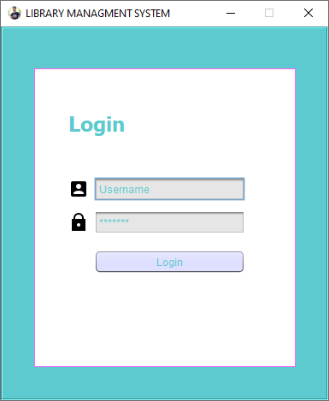

fig. 1 Login

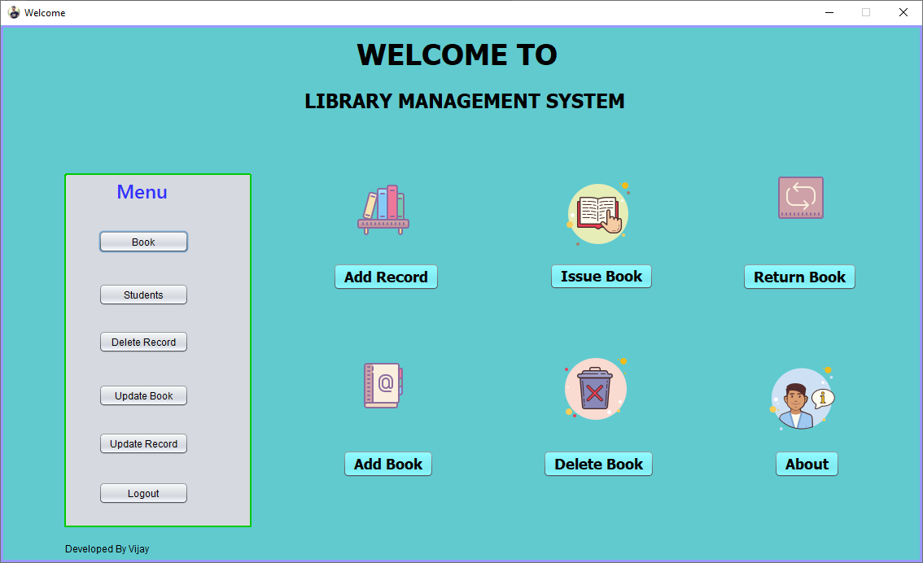
fig. 2 Main Window
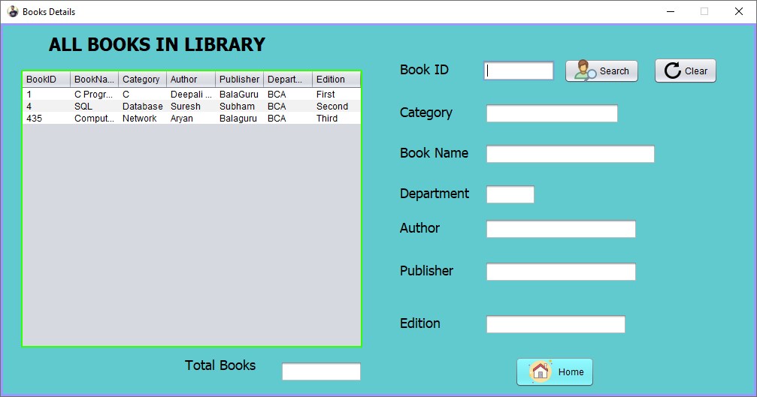
fig. 3 All Books In Library

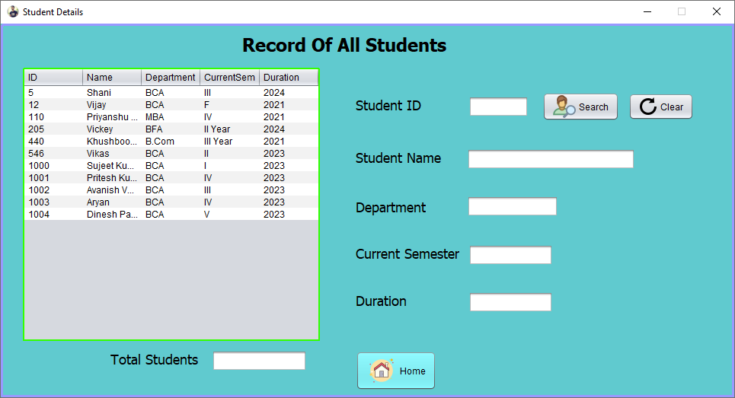
fig. 4 All Student Record
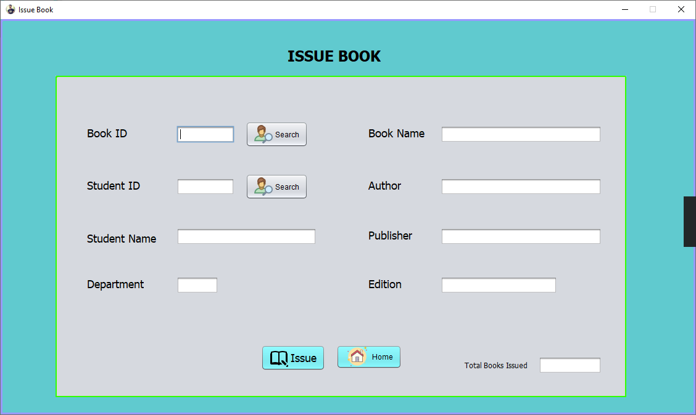
fig. 5 Issue Book

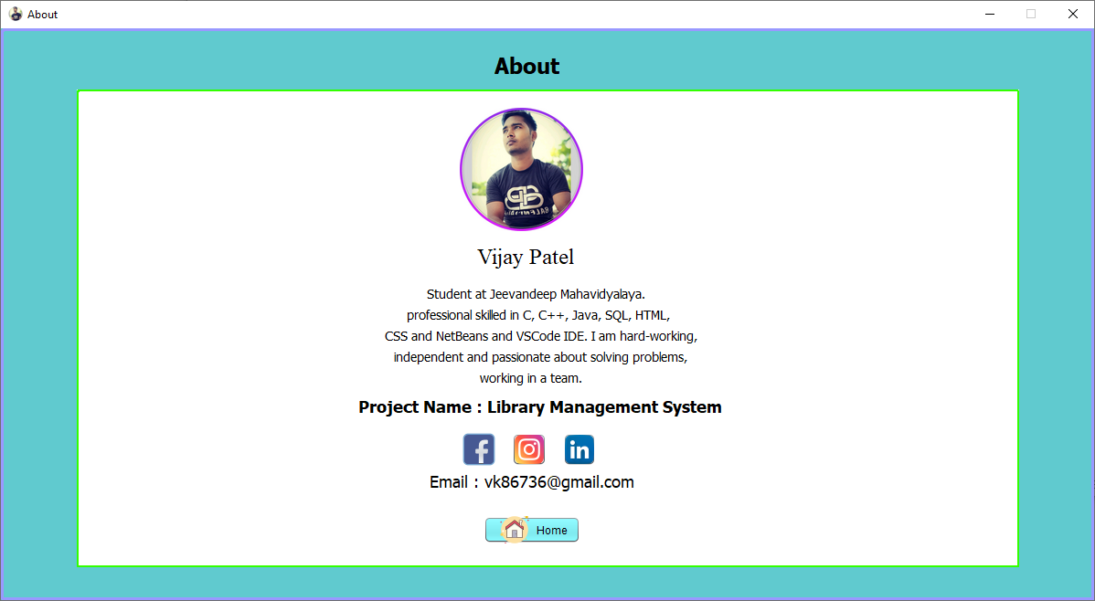
fig. 6 About Page

SOURCE CODE

Password Verification

private void ButtonLoginActionPerformed(java.awt.event.ActionEvent evt) {
String Username = UsernameField.getText();
String Pass = PasswordField.getText();
if(Username.equals("Vijay")&& Pass.equals("123"))
{
Main m = new Main();
this.hide();
m.setVisible(true);
}
else
{
JOptionPane.showMessageDialog(this, "Username or Password Do Not Match");
UsernameField.setText("");
PasswordField.setText("");
UsernameField.requestFocus();
}
}

Home Page

private void ButtonAboutActionPerformed(java.awt.event.ActionEvent evt) {
About m = new About();
this.hide();
m.setVisible(true);
JOptionPane.showMessageDialog(null,"Welcome User ! ");
}
private void ButtonDeleteBookActionPerformed(java.awt.event.ActionEvent evt) {
DeleteBook m = new DeleteBook();
this.hide();
m.setVisible(true);
}
private void ButtonAddBookActionPerformed(java.awt.event.ActionEvent evt) {
AddBook m= new AddBook();
this.hide();
m.setVisible(true);
}
private void ButtonReturnBookActionPerformed(java.awt.event.ActionEvent evt) {
ReturnBook m = new ReturnBook();

this.hide();
m.setVisible(true);
}
private void ButtonIssueBookActionPerformed(java.awt.event.ActionEvent evt) {
IssueBook m = new IssueBook();
this.hide();
m.setVisible(true);
}
private void ButtonAddRecordActionPerformed(java.awt.event.ActionEvent evt) {
AddRecord m = new AddRecord();
this.hide();
m.setVisible(true);
}
private void LogoutButtonActionPerformed(java.awt.event.ActionEvent evt) {
Login m = new Login();
this.hide();
m.setVisible(true);
}
private void IssueButtonActionPerformed(java.awt.event.ActionEvent evt) {
UpdateBook m = new UpdateBook();
this.hide();
m.setVisible(true);
}
private void BookButtonActionPerformed(java.awt.event.ActionEvent evt) {
Book m = new Book();
this.hide();
m.setVisible(true);
}
private void MemberButtonActionPerformed(java.awt.event.ActionEvent evt) {
Student m = new Student();
this.hide();
m.setVisible(true);
}
private void DeleteBookButtonActionPerformed(java.awt.event.ActionEvent evt) {
DeleteRecord m = new DeleteRecord();
this.hide();
m.setVisible(true);
}

private void ReturnButtonActionPerformed(java.awt.event.ActionEvent evt) {
UpdateRecord m = new UpdateRecord();
this.hide();
m.setVisible(true);
}

Add Book

private void AddBookButtonActionPerformed(java.awt.event.ActionEvent evt) {
try{
Class.forName("org.sqlite.JDBC");
try (Connection conn = DriverManager.getConnection("jdbc:sqlite:C:\\Users\\Vijay\\Documents\\NetBeansProjects\\Library_Managment_System\\temp.db")) {
String sql = "insert into bookrecord (BookID,BookName,Category,Author,Publisher,Department,Edition) values (?,?,?,?,?,?,?)";
PreparedStatement pstmt = conn.prepareStatement(sql);
pstmt.setInt(1,Integer.parseInt(FieldBookId.getText()));
pstmt.setString(2,FieldBookName.getText());
pstmt.setString(3,FieldCategory.getText());
pstmt.setString(4,FieldBookAuthor.getText());
pstmt.setString(5,FieldBookPublisher.getText());
pstmt.setString(6,FieldDepartment.getText());
pstmt.setString(7,FieldBookEdition.getText());
pstmt.executeUpdate();
JOptionPane.showMessageDialog(this, "Record Inserted");
FieldBookId.setText("");
FieldCategory.setText("");
FieldDepartment.setText("");
FieldBookName.setText("");
FieldBookAuthor.setText("");
FieldBookPublisher.setText("");
FieldBookEdition.setText("");
FieldBookId.requestFocus();
}
}catch(SQLException e)
{
JOptionPane.showMessageDialog(this, "System Error");
} catch (ClassNotFoundException ex) {
Logger.getLogger(AddBook.class.getName()).log(Level.SEVERE, null, ex);
}
}

ADD RECORD

private void AddRecordButtonActionPerformed(java.awt.event.ActionEvent evt) {
try{
Class.forName("org.sqlite.JDBC");
Connection conn = DriverManager.getConnection("jdbc:sqlite:C:\\Users\\Vijay\\Documents\\NetBeansProjects\\Library_Managment_System\\temp.db");
String sql = "insert into studentdetails (ID,Name,Department,CurrentSem,Duration) values (?,?,?,?,?)";
PreparedStatement pstmt = conn.prepareStatement(sql);

pstmt.setInt(1,Integer.parseInt(FieldStudentId.getText()));
pstmt.setString(2,FieldStudentName.getText());
pstmt.setString(3,FieldDepartment.getText());
pstmt.setString(4,FieldCurrentYear.getText());
pstmt.setString(5,FieldDuration.getText());
pstmt.executeUpdate();
JOptionPane.showMessageDialog(null,"Record Inserted Successfully");
FieldStudentId.setText("");
FieldStudentName.setText("");
FieldDepartment.setText("");
FieldCurrentYear.setText("");
FieldDuration.setText("");
FieldStudentId.requestFocus();
conn.close();
}catch(Exception e){
JOptionPane.showMessageDialog(null,e);
}
}

VIEW & SEARCH BOOK

private void SearchBookActionPerformed(java.awt.event.ActionEvent evt) {
try{
Class.forName("org.sqlite.JDBC");
Connection conn = DriverManager.getConnection("jdbc:sqlite:C:\\Users\\Vijay\\Documents\\NetBeansProjects\\Library_Managment_System\\temp.db");

String sql = "select *from bookrecord where BookID = ?";
PreparedStatement pstmt = conn.prepareStatement(sql);
pstmt.setInt(1,Integer.parseInt(FieldBookId.getText()));
ResultSet rs = pstmt.executeQuery();
if(rs.next()){
FieldBookName.setText(rs.getString("BookName"));
FieldCategory.setText(rs.getString("Category"));
FieldDepartment.setText(rs.getString("Department"));
FieldBookAuthor.setText(rs.getString("Author"));
FieldBookPublisher.setText(rs.getString("Publisher"));
FieldBookEdition.setText(rs.getString("Edition"));
}
else{
JOptionPane.showMessageDialog(null,"Record Not Found");
}
conn.close();
}catch(Exception e){
JOptionPane.showMessageDialog(null,e);
}
}

DELETE BOOK

private void DeleteButtonActionPerformed(java.awt.event.ActionEvent evt) {
try{
Class.forName("org.sqlite.JDBC");
Connection conn = DriverManager.getConnection("jdbc:sqlite:C:\\Users\\Vijay\\Documents\\NetBeansProjects\\Library_Managment_System\\temp.db");
String sql = "delete from bookrecord where BookID = ?";
PreparedStatement pstmt = conn.prepareStatement(sql);
pstmt.setInt(1,Integer.parseInt(FieldBookId.getText()));
pstmt.executeUpdate();
JOptionPane.showMessageDialog(this,"Book With ID = "+FieldBookId.getText()+" Has Been Deleted Successfully ");
FieldBookId.setText("");
FieldBookName.setText("");
FieldBookAuthor.setText("");
FieldBookPublisher.setText("");
FieldBookEdition.setText("");
FieldBookId.requestFocus();
conn.close();
}catch(Exception e){
JOptionPane.showMessageDialog(null,e);
}
}

DELETE RECORD

private void DeleteRecordButtonActionPerformed(java.awt.event.ActionEvent evt) {
try{
Class.forName("org.sqlite.JDBC");
Connection conn = DriverManager.getConnection("jdbc:sqlite:C:\\Users\\Vijay\\Documents\\NetBeansProjects\\Library_Managment_System\\temp.db");
String sql = "delete from studentdetails where ID = ?";
PreparedStatement pstmt = conn.prepareStatement(sql);
pstmt.setInt(1,Integer.parseInt(FieldStudentId.getText()));
pstmt.executeUpdate();
JOptionPane.showMessageDialog(null,"Record Deleted Successfully");
FieldStudentId.setText("");
FieldStudentName.setText("");
FieldDepartment.setText("");
FieldCurrentYear.setText("");
FieldDuration.setText("");
FieldStudentId.requestFocus();
conn.close();
}catch(Exception e){
JOptionPane.showMessageDialog(null,e);
}
}

ISSUE BOOK

private void IssueButtonActionPerformed(java.awt.event.ActionEvent evt) {
try{
Class.forName("org.sqlite.JDBC");
try (Connection conn = DriverManager.getConnection("jdbc:sqlite:C:\\Users\\Vijay\\Documents\\NetBeansProjects\\Library_Managment_System\\temp.db")) {
String sql = "insert into issuebook (BookID,StudentID,StudentName,Department,BookName,Author,Publisher,Edition) values (?,?,?,?,?,?,?,?)";
PreparedStatement pstmt = conn.prepareStatement(sql);
pstmt.setInt(1,Integer.parseInt(FieldBookId.getText()));
pstmt.setInt(2,Integer.parseInt(FieldStudentId.getText()));
pstmt.setString(3,FieldStudentName.getText());
pstmt.setString(4,FieldDepartment.getText());
pstmt.setString(5,FieldBookName.getText());
pstmt.setString(6,FieldBookAuthor.getText());
pstmt.setString(7,FieldBookPublisher.getText());
pstmt.setString(8,FieldBookEdition.getText());
pstmt.executeUpdate();
JOptionPane.showMessageDialog(this,"Book With ID = "+FieldBookId.getText()+" Has Been Issued To "+FieldStudentName.getText()+", Successfully ");
FieldBookId.setText("");
FieldStudentId.setText("");
FieldDepartment.setText("");
FieldDepartment.setText("");
FieldBookName.setText("");
FieldBookAuthor.setText("");
FieldBookPublisher.setText("");
FieldBookEdition.setText("");
FieldBookId.requestFocus();
}
}catch(SQLException e)
{
if(e.getErrorCode()==1062)
JOptionPane.showMessageDialog(this,"This Book is Taken By Someone, A Student Can Only Get A Single Book From Library At A Time ");
} catch (ClassNotFoundException ex) {
Logger.getLogger(AddBook.class.getName()).log(Level.SEVERE, null, ex);
}
}

RETURN BOOK

private void ReturnButtonActionPerformed(java.awt.event.ActionEvent evt) {
try{
Class.forName("org.sqlite.JDBC");
Connection conn = DriverManager.getConnection("jdbc:sqlite:C:\\Users\\Vijay\\Documents\\NetBeansProjects\\Library_Managment_System\\temp.db");
String sql = "delete from issuebook where BookID = ?";
PreparedStatement pstmt = conn.prepareStatement(sql);
pstmt.setInt(1,Integer.parseInt(FieldBookId.getText()));
pstmt.executeUpdate();
JOptionPane.showMessageDialog(this,"Book With ID = "+FieldBookId.getText()+" Has Been Returned From "+FieldStudentName.getText()+", Successfully ");
FieldBookId.setText("");
FieldBookName.setText("");
FieldStudentName.setText("");
FieldDepartment.setText("");
FieldStudentId.setText("");
FieldBookAuthor.setText("");
FieldBookPublisher.setText("");
FieldBookEdition.setText("");
FieldBookId.requestFocus();
conn.close();
}catch(Exception e){
JOptionPane.showMessageDialog(null,e);
}
}

VIEW & SEARCH STUDENT

private void SearchButtonActionPerformed(java.awt.event.ActionEvent evt) {
try{
Class.forName("org.sqlite.JDBC");
Connection conn = DriverManager.getConnection("jdbc:sqlite:C:\\Users\\Vijay\\Documents\\NetBeansProjects\\Library_Managment_System\\temp.db");
String sql = "select *from studentdetails where ID = ?";
PreparedStatement pstmt = conn.prepareStatement(sql);
pstmt.setInt(1,Integer.parseInt(FieldStudentId.getText()));
ResultSet rs = pstmt.executeQuery();
if(rs.next()){
FieldStudentName.setText(rs.getString("Name"));
FieldDepartment.setText(rs.getString("Department"));
FieldCurrentYear.setText(rs.getString("CurrentSem"));
FieldDuration.setText(rs.getString("Duration"));
}
else{
JOptionPane.showMessageDialog(null,"Record Not Found");
}
conn.close();
}catch(Exception e){
JOptionPane.showMessageDialog(null,e);
}
}

UPDATE BOOK

private void UpdateButtonActionPerformed(java.awt.event.ActionEvent evt) {
try{
Class.forName("org.sqlite.JDBC");
try (Connection conn = DriverManager.getConnection("jdbc:sqlite:C:\\Users\\Vijay\\Documents\\NetBeansProjects\\Library_Managment_System\\temp.db")) {
String sql;
sql = "update bookrecord set BookName = ?, Category = ?, Author = ?, Publisher = ?, Department = ?, Edition = ? where BookID = ?";
PreparedStatement pstmt = conn.prepareStatement(sql);
pstmt.setString(1,FieldBookName.getText());
pstmt.setString(2,FieldCategory.getText());
pstmt.setString(3,FieldBookAuthor.getText());
pstmt.setString(4,FieldBookPublisher.getText());
pstmt.setString(5,FieldDepartment.getText());
pstmt.setString(6,FieldBookEdition.getText());
pstmt.setInt(7, Integer.parseInt(FieldBookId.getText()));
pstmt.executeUpdate();
JOptionPane.showMessageDialog(null,"Record Update Successfully");
FieldBookName.setText("");
FieldDepartment.setText("");
FieldCategory.setText("");
FieldBookAuthor.setText("");
FieldBookPublisher.setText("");
FieldBookEdition.setText("");
FieldBookId.requestFocus();
conn.close();
}
}catch(HeadlessException | ClassNotFoundException | SQLException e){
JOptionPane.showMessageDialog(null,e);
}
}

UPDATE STUDENT RECORD

private void UpdateButtonActionPerformed(java.awt.event.ActionEvent evt) {
try{
Class.forName("org.sqlite.JDBC");
try (Connection conn = DriverManager.getConnection("jdbc:sqlite:C:\\Users\\Vijay\\Documents\\NetBeansProjects\\Library_Managment_System\\temp.db")) {
String sql;
sql = "update studentdetails set Name = ?, Department = ?, CurrentSem = ?, Duration = ? where ID = ?";
PreparedStatement pstmt = conn.prepareStatement(sql);
pstmt.setString(1,FieldStudentName.getText());
pstmt.setString(2,FieldDepartment.getText());
pstmt.setString(3,FieldCurrentYear.getText());
pstmt.setString(4,FieldDuration.getText());
pstmt.setInt(5, Integer.parseInt(FieldStudentId.getText()));
pstmt.executeUpdate();
JOptionPane.showMessageDialog(null,"Record Update Successfully");
FieldStudentName.setText("");
FieldDepartment.setText("");
FieldCurrentYear.setText("");
FieldDuration.setText("");
FieldStudentId.requestFocus();
}
}catch(HeadlessException | ClassNotFoundException | SQLException e){
JOptionPane.showMessageDialog(null,e);
}
}

FUTURE SCOPE

- Messaging system.
- Comments.
- Like Dislike
- Online Book Reading.
- Download Book.
- Fine Caculation.
- Students can also create their account.
- Improving Security.

